**A PROJECT REPORT**

**ON**

**“SMART NOTICE BOARD”**

**[UDP]**

**PREPARED BY:**

TAMOGHNA CHATTOPADHYAY (130070110070)

SURBHI SINGHAL (130070110068)

MILI MODI (130070110039)

SUBHAM CHAUHAN (130070110082)

**GUIDED BY:**

**Prof MehfuzaHolia**

**A Project Submitted to**

**GUJARAT TECHNOLOGICAL UNIVERSITY**

**In Partial Fulfillment of Requirements for**

**The Degree of Bachelor of Engineering In**

**ELECTRONICS**



**BIRLA VISHVAKARMA MAHAVIDYALAYA**

**VALLABH VIDHYA NAGAR-388120**

**Gujarat Technological University, Ahmedabad**

**November, 2016**

**Acknowledgement**

At the outset, we take this opportunity to express our deep gratitude to few individuals who guided us in every aspect of our project. Without their support and guidance, the project work would not have been completed. This project provided us an opportunity to put our theoretical knowledge into practical use and enhance our understanding of various subjects.

We are deeply grateful to our internal guide Dr Mehfuza Holia for her constant guidance and motivation to complete the assigned work on time and how to improve to the next level. She showed us the correct way to approach our project work. Without her experience and knowledge, it would have been very difficult to do quality work in the given time period.

We are also grateful to Prof Kaushika D Patel for providing us timely proper guidance and motivation to innovate the project. We individually would like to thank our group mates for their delightful company which kept us in good humour throughout the term.

We would like to take this opportunity to thank Dr T D Pawar (Head), Electronics Department and Prof D L Vala (Project Coordinator) for their guidance and constant support during the entire project term.

At last but not the least we are thankful to all our classmates who helped us directly or indirectly in our project.

**Abstract**

This is an embedded based project. An embedded system is a fusion of software and hardware and perhaps other mechanical parts designed to perform a specific function. A Notice Board is a very essential device in any institution / organization or public utility place like airports, shopping malls and stadium.

The main aim of this project is to design an SMS driven automatic display which reduces the manual operation. The information can in turn be updated instantly at the desired location. Updates can be done in individual displays without disturbing other displays. The message to be displayed is sent as an SMS to a GSM receiver module. This message is then stored in PC and is sent to the LCD displays through the controller. The messages stored in the computer acts as a record for future reference.

To make our notice board more effective and user friendly, we have thought of using some other technologies to provide communication between the user and the LCD display.

1. SMS based system using GSM module.

2. Wi-Fi based system using IEEE 802.11 standard.

3. Usage of Android Application to access the notices which have been displayed.

Some other features that can be included in our project are:

* Maintenance of the database of all the previous notices on a hard disk.
* Each student can access his/her data, for example- his/her marks in all the subjects, assignments allotted, attendance etc. through an android application using login ID/password.

**TABLE OF CONTENTS**

|  |  |
| --- | --- |
| **Title** | **Page No** |
| **ACKNOWLEDGEMENT** | 2 |
| **ABSTRACT** | 3 |
| **TABLE OF CONTENTS** | 4 |
| **LIST OF TABLES** | 6 |
| **LIST OF FIGURES** | 7 |
| **CHAPTER 1: INTRODUCTION**  **1.1 DEFINITION**  **1.2 INTRODUCTION**  **1.3 OBJECTIVE**   * 1. **LITERATURE REVIEW**   1.4.1 Smart Notice Board  1.4.2 Password Protected Multiuser Wireless Electronic(IEEE)  1.4.3 SMS based Wireless Notice board with Monitoring system  1.4.4 Wireless Digital Notice Board Using GSM Technology  1.4.5 Wireless Electronic Notice Board Using GSM Technology  1.4.6 Display Message on Notice Board using GSM   * 1. **TOOLS REQUIRED**   1.5.1 Hardware   * + 1. Software | 8  9  10  13 |
| **CHAPTER 2 : LITERATURE REVIEW**  **2.1 RASPBERRY PI**  2.1.1 What is the Raspberry Pi?  2.1.2 Hardware Features  2.1.2 .1 Processor  2.1.2.2 Performance  2.1.3 Software Features  2.1.3.1 Operating System  2.1.3.2 Driver APIs  **2.2 SIM 900-TTL UART GSM/GPRS MODEM**  2.2.1 What is the SIM 900-TTL UART GSM MODEM?  2.2.2 Features  2.2.3 Specifications 2.3 Edimax EW-7811Un 150Mbps 11n Wi-Fi USB Adapter2.3.1 Features **2.4 CANVAS**  2.4.1 AEIOU SUMMARY   * + 1. EMPATHY CANVAS   2.4.3 IDEATION CANVAS  2.4.4 PRODUCT DEVELOPMENT CANVAS  2.4.5 BUSINESS MODEL CANVAS | 14  15  15  16  17  19  20  21  21  23  26  28  31 |
| **CHAPTER 3:BLOCK DIAGRAM, PROJECT DESIGN AND SYSTEM COMPONENTS**  **3.1BLOCK DIAGRAM**   * 1. **COMPONENTS USED**   2. **PROCESS FLOW**   3. **OVERVIEW TO COMPONENTS USED**   **3.5 HOW TO LOAD OS IN RASPBERRY PI USING WINDOWS 8**  **3.6 HOW TO ACCESS RASPBERRY PI USING ETHERNET CABLE** | 34  35  35  36  37  38  42 |
| **CHAPTER 4: INTERFACING GSM WITH VARIOUS MODULE**   * 1. **GSM MODEM SIM900AWITH RASPBERRY Pi 3**   **4.2INTERFACING OF RASPBERRY Pi 3 WITH WIFI**  **4.3 DEVELOPING OF AN ANDROID APP**  **4.4 INTERFACING OF RASPBERRY WITH GOOGLE DRIVE** | 47  48  51  53  57 |
| **CHAPTER 5: PRACTICAL WORKING OF MODULE**  **5.1 STEPS**  **CHAPTER 6: SUMMARY**  **6.1 SUMMARY**  **6.2 ADVANTAGES**  **6.3 FUTURE WORK**  **REFERENCES** | 59  60  63  64  64  64  65 |

**LIST OF TABLES**

|  |  |  |
| --- | --- | --- |
| **SR.NO** | **TITLE** | **Page No** |
| Table:1  Table:2  Table:3  Table:4  Table:5  Table:6 | Specification of Raspberry Pi 3 Model B  Connectors of Raspberry Pi  General Impression activity of AEIOU Canvas  General Impressions and Observations of users under AEIOU  Activities classification under Empathy canvas  Situation /context/ location classification of Ideation Canvas | 18  18  21  23  24  27 |

**LIST OF FIGURES**

|  |
| --- |
| **Figure- 1: Raspberry Pi 2 15**  **Figure- 2: Hardware Diagram 16**  **Figure- 3: Specification Diagram 17**  **Figure- 4: : AEIOU Summary Canvas 21**  **Figure- 5: Empathy Canvas 23**  **Figure- 6: Ideation canvas 26**  **Figure- 7: Product Development Canvas 28**  **Figure 8 : Business Model Canvas 31**  **Figure- 9: Basic Block Diagram 35**  **Figure- 10: Flow Diagram Of The System 36**  **Figure- 11: Stuffs Required to Load OS in Raspberry Pi 38**  **Figure- 12:Raspbian Image39**  **Figure- 13: Win32disk Imager 39**  **Figure- 14: SD Card Formatting 40**  **Figure- 15: Loading the Image using Win32Disk Imager 40**  **Figure- 16: Insert SD Card to Raspberry Pi 41**  **Figure- 17: Supply, Ethernet and Data Cable Connection to Pi 42**  **Figure- 18: Command to Check IP Address of Machine 42**  **Figure- 19: Command to Check Connection between Pi and PC 43**  **Figure- 20: PuTTY Configuration1 44**  **Figure- 21: PuTTY Configuration2 44**  **Figure-22: window- PuTTY 45**  **Figure- 23: Window Pi Terminal 45**  **Figure -24: Desktop Screen on Window 46**  **Figure 25 : Interfacing of GSM with Raspberry Pi 48**  **Figure 26 : Sending message to Raspberry 50**  **Figure 27 : ON the wifi module on raspberry pi 51**  **Figure 28 : select the wifi network 51**  **Figure 29 : Entering the passkey 52**  **Figure 30 : installation of android app 53**  **Figure 31: Selection of the project 54**  **Figure 32 :Editing of welcome message 54**  **Figure 33 : Adding activity button 55**  **Figure 34 : Addition of second activity button 55**  **Figure 35 : Button’s on click method 56**  **Figure 36 : Testing the application 56**  **Figure 37 : Running python program 60**  **Figure 38 : Python program checks the connectivity 60**  **Figure 39 : Sending message through sms 61**  **Figure 40 : Message displayed on Lcd screen 61**  **Figure 41 : Message stored on google sheet 62**  **Figure 42 : Accessing message through android app 62** |

**Chapter 1**

**INTRODUCION**

CHAPTER 1 INTRODUCTION

* 1. **DEFINITION**

Implementation of a smart notice board which uses both GSM module and Wifi based interconnection with the hardware module for user interaction.

* 1. **INTRODUCTION**

In any sector / organization a notice board is an essential device mostly in public place like airports, shopping malls and stadium. Institutions like schools and colleges make use of paper notices or at most sms systems to pass off notices and messages throughout the institution. This system is both cumbersome and difficult to manage and keep track of.

Our project ‘SMART NOTICE BOARD’ is implementation of a smart and intelligent notice board which can electronically keep track of different notices, display it on screens and provide instant access to the members of the institution. As in our day to day life we utilise many electronic devices like smart phones and electronic pads, our project is a step towards providing interfacing for an electronic access to important notices and messages which are circulated in an institution.

Our project aims at interfacing a microcontroller or raspberry pi board to alcd screen where all the notices will be shown. The notice board can be accessed through verified users using either wifi systems in their mobiles and laptops or through GSM module provided in mobiles. Once a user has been verified, the notice will be displayed on the screen. The notice will also be stored in an online database through cloud computing technology where a database will be created and all information will be stored using raspberry pi board. An android application will also be provided for an user to remotely access the notice board.

A security check is also provided by the notice board to ensure that only registered users are allowed access to the notice board. Also the database will store all the notices and information for easier access later down the years.

**1.3 OBJECTIVE**

Main goals of the project are:

* To understand the basics of Raspberry Pi board and it’s interfacing with various peripherals like LCD screen, GSM module and Wifi module
* To understand the concept of cloud computing
* To understand construction and maintenance of online database using Raspberry Pi board and cloud computing.
* To construct an android application through which the database can be accessed.
* To study the different components used in the project
* To construct a software program that will run on the module.
* To construct hardware module and software program and test it’s working
* To design a hardware module of the whole system.

**1.4 LITERATURE REVIEW**

The journey started with the aim of searching for a project beneficial to the society. We found that a smart notice board system is not available in most institutions. So we felt a need of a system which can useful to society.

We referred following research papers which may somehow useful to our project in different parts of our project.

1. **SMART NOTICE BOARD(IEEE)**

*“Shruthi K. 1 ,HarshaChawla 2 , AbhishekBhaduri 3”*

This technical paper shares its data on present day technology and how precisely, simple carry-to-use devices play an essential role in present generation and will be of great comfort for the upcoming generation. Using the existing technological devices, how an efficient and smart notice board can be designed is explained in this paper. This model is used where any information have to be given to a large number of people. For example in public places like airports, shopping mall, colleges, parks etc.

1. **Password Protected Multiuser Wireless Electronic(IEEE)**

*“Noticing System by GSM with Robust Algorithm”*

This paper is about a wireless digital noticing system providing information in an innovative and wise manner. The notice board design here is a multiuser password-protected SMS- based system fabricated with an LCD. The sharing of data transfer between the verified user and the LCD display unit is done with the help ofGSM techniqueto ensure remote display facilities, such that any notice can be displayed on the electronic board from the user’s mobile SMS from distant places. To assure system design, a multiuser monitoring and displaying system has been executed in the system which is used to display several notices simultaneously. In addition, the user also can print any notice which is of concern to them. The total system is designed with simple logic with a robust algorithm and fabricated with a PIC midrange microcontroller, LCD, GSM module and other commercially available electronic devices to ensure efficiency and reliability with less cost.

|  |
| --- |
| 1. **SMS based Wireless Notice board with Monitoring system** |
| *“Nivetha S. R, Pujitha. R, PreethiSelvaraj&Yashvanthini S.M Electronics and Communication Engineering, Avinashilingam University for Women-Engineering College Coimbatore, India”.* |

In this project the controller ARM-LPC2148 is interfaced with Graphical Display. At present, where data has to be updated in a notice board, it was done manually. Also we have seen thatin electronic systems, no matter how many number of displays are present, only a single notice can be sent to all of the notice boards irrespective of their places. To overcome this disadvantage, a decoder along with a multiple display is used to choose a particular display and then the corresponding data is transmitted through the ARM controller by using GSM technology. The entries can be filed and a record may be kept for further use by using visual basic. The controller is embedded with an internal real time clock used for synchronization of data. The monitoring system comprises of an image sensor which captures the images for the specified amount of time and then the images can be transferred to the system for storage through an USB port to a Personal Computer.A resistive touch screen is used to access the past notices and also progress details

1. **Wireless Digital Notice Board Using GSM Technology**

*“Mr.Ramchandra K. Gurav1, Mr.RohitJagtap*

*1 Assistant Professor, Electronics & Telecommunication Engineering Department, Dr.DaulatraoAher College of Engineering, Karad , Maharashtra, India.*

*2 Student -, Electronics & Telecommunication Engineering Department, Dr.DaulatraoAher College of Engineering, Karad , Maharashtra, India”*

In this proposed system the idea of wireless Digital Notice Board Using GSM Technology has been presented. So our main aim is to reduce paper work and time. In this paper we are trying to implement our system in such a way that it can display message from authorized user sends to GSM module which is located on the notice board. So in short, the GSM module which is located at Digital notice board receives the message from authorized user and displayed on notice board which is situated at remote location, at same time this message will be sent to different users’ mobile numbers that are stored in microcontroller memory. So spreading of important data or notice will takes place within very short duration of time to each mobile no’s respectively. Means user or registered person can able to send the message from anywhere and this message is displayed on LCD display.

1. **International Journal for Research in Applied Science & Engineering Technology (IJRASET)**

**Wireless Electronic Notice Board Using GSMTechnology**

*“Masood Khan1, Pratik Bhosale2, Sandesh Dalvi3*

*DR. D Y Patil School Of Engineering, E&TC Dept. SavitribaiPhule, Pune Universit”*

With the advancement in technology nowadays, the wireless communication is justifying its statement in each and every field of the present generation. The above paper discussed is based on wireless technology like GSM for controlling electronic notice boards using LPC2148 microcontroller IC. The proposed system comprises of hardware as well as software. The hardware module constitutes of GSM modem, computer interface, microcontroller, monitoring system, and LCD and GLCD display. The software module also consists of MATLAB based GUI so as to monitor the information to be displayed on notice board efficiently as well as enter in the notices through the computer were the GUI is been used.

1. **Display Message on Notice Board using GSM**

**Foram Kamdar1, Anubbhav Malhotra2 and Pritish Mahadik3**

*“1Department of Electronics and Telecommunications, Mumbai University,*

*S.P.I.T, Andheri West, Mumbai, INDIA.*

*2,3Department of Electronics and Telecommunications, Mumbai University,*

*S.P.I.T, Andheri West, Mumbai, INDIA.”*

A notice board is an elementary matter in any institution or organization or public utility places like bus airports, railway stations or shopping malls. Sending notices on the daily basis is a slow process. So we have looked into this paper as it deals with advancement of notice board. It includes an SMS based notice board incorporating the use of GSM to facilitate the communication of displaying message on notice board through the user’s mobile phone. This system is controlled by a microcontroller ATMEGA32 programmed in assembly language. A SIM card withSIM300 GSM modem is interfaced to the microcontroller port with the help of AT commands. When the user transmits a data by SMS via a registered phone number, it is received by SIM300 GSM modem at the receiver’s end. The interfacing of SIM300 is duly done by a level shifter IC MAX32 to the microcontroller. The messaged is thus delivered into the microcontroller. The fetched message is displayed on an electronic notice board which is connected with LCD display interfaced to microprocessor powered by a regulated power supply of 230 volts ac from main supply.

**1.5 TOOLS REQUIRED**

Hardware

* Raspberry Pi Board
* GSM Module
* Wifi Module
* Graphical Liquid Crystal Display (GLCD)
* On chip DAC (Digital to analog converter)
* Wires and cables for interconnection

Software

* Keiluvision 4
* Eclipse IDE
* Raspbian OS
* Python
* Xampp
* Xming
* Notepad
* Win32 Disk Imager
* SD Card Formatter
* Putty

**Chapter 2**

**LITERATURE REVIEW**

CHAPTER 2 LITERATURE REVIEW

**2.1 RASPBERRY PI**

2.1.1 What is the Raspberry Pi?

The Raspberry Pi is a series of credit card-sized single-board computers developed in the United Kingdom by the Raspberry Pi Foundation.

All models feature a [Broadcom](https://en.wikipedia.org/wiki/Broadcom) [system on a chip](https://en.wikipedia.org/wiki/System_on_a_chip) (SoC) , which includes an [ARM](https://en.wikipedia.org/wiki/ARM_architecture) compatible [central processing unit](https://en.wikipedia.org/wiki/Central_processing_unit) (CPU) and an on chip [graphics processing unit](https://en.wikipedia.org/wiki/Graphics_processing_unit) (GPU, a [VideoCore](https://en.wikipedia.org/wiki/VideoCore) IV). The CPU speed for the pi3 varies from 700 MHz to 1.2 GHz and 256 MB to 1 GB RAM for on board memory . The operating system is stored by a [Secure Digital](https://en.wikipedia.org/wiki/Secure_Digital) (SD) cards and the program memory in stored either in the SDHC or Micro SDHC sizes. Most boards come with one tofour USB slots, [HDMI](https://en.wikipedia.org/wiki/HDMI) and [composite video](https://en.wikipedia.org/wiki/Composite_video) output, and a 3.5 mm phone jack for audio. The GPIO pins provide a lower level of output which supports common protocols like [I²C](https://en.wikipedia.org/wiki/I%C2%B2C). The B-models is equipped with an [8P8C](https://en.wikipedia.org/wiki/8P8C) [Ethernet](https://en.wikipedia.org/wiki/Ethernet) port and the Wi-Fi 802.11n and [Bluetooth](https://en.wikipedia.org/wiki/Bluetooth) are placed on board of Pi 3 .

The Foundation provides [Raspbian](https://en.wikipedia.org/wiki/Raspbian), a Debian-based [Linux distribution](https://en.wikipedia.org/wiki/Linux_distribution) for download, as well as third party [Ubuntu](https://en.wikipedia.org/wiki/Ubuntu_(operating_system)), [Windows 10 IOT Core](https://en.wikipedia.org/wiki/Windows_10_IoT_Core), [RISC OS](https://en.wikipedia.org/wiki/RISC_OS), and specialised [media center](https://en.wikipedia.org/wiki/OpenELEC) distributions. It promotes [Python](https://en.wikipedia.org/wiki/Python_(programming_language)) and [Scratch](https://en.wikipedia.org/wiki/Scratch_(programming_language)) as the main programming language, with support for many other languages. The default [firmware](https://en.wikipedia.org/wiki/Firmware) is [closed source](https://en.wikipedia.org/wiki/Closed_source), while an unofficial [open source](https://en.wikipedia.org/wiki/Open_source) is available.

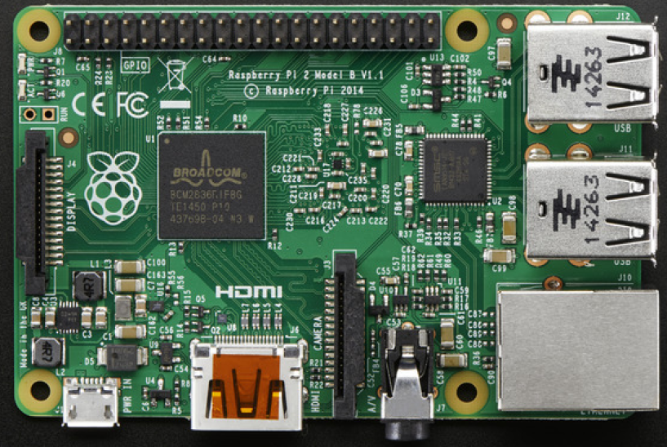

Figure : Raspberry Pi-3

**2.1.2 Hardware Features**

2.1.2.1 Processor

The first generation Raspberry Pi comprises a[Broadcom](https://en.wikipedia.org/wiki/Broadcom) BCM2835 SoC which is somewhat equivalent to the chip used in first generation [smartphones](https://en.wikipedia.org/wiki/Smartphone) (its CPU is an older [ARMv6](https://en.wikipedia.org/wiki/ARM11) architecture), which includes a 700 [MHz](https://en.wikipedia.org/wiki/Hertz) [ARM11](https://en.wikipedia.org/wiki/ARM11)76JZF-S processor, [VideoCore](https://en.wikipedia.org/wiki/VideoCore) IV [graphics processing unit](https://en.wikipedia.org/wiki/Graphics_processing_unit) (GPU), and RAM. It has a level 1 (L1) [cache](https://en.wikipedia.org/wiki/CPU_cache) of 16 [KB](https://en.wikipedia.org/wiki/Kibibyte) and a level 2 (L2) cache of 128 KB. The GPU primarily uses a level 2 cache . The SoC is [stacked](https://en.wikipedia.org/wiki/Package_on_package) underneath the glued to RAM chip, so only its edge is visible.

The Raspberry Pi 2 uses a Broadcom BCM2836 SoC with a 900 MHz 32-bit quad-core [ARM Cortex-A7](https://en.wikipedia.org/wiki/ARM_Cortex-A7) processor (as do many current smartphones), with 256 KB shared L2 cache.

The Raspberry Pi 3 uses a Broadcom BCM2837 SoC with a 1.2 GHz 64-bit quad-core [ARM Cortex-A53](https://en.wikipedia.org/wiki/ARM_Cortex-A53) processor, with 512 KB shared L2 cache.

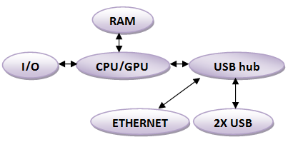

Figure 2: Hardware Diagram

2.1.2.2 Performance

While operating at 700 MHz by default, the first generation Raspberry Pi provided a real-world performance roughly equivalent to 0.041 [GFLOPS](https://en.wikipedia.org/wiki/FLOPS). On the [CPU](https://en.wikipedia.org/wiki/Central_processing_unit) level the performance is similar to a 300 MHz [Pentium II](https://en.wikipedia.org/wiki/Pentium_II) of 1997–99. The GPU provides 1 [Gpixel](https://en.wikipedia.org/wiki/Gpixel)/s or 1.5 [Gtexel](https://en.wikipedia.org/wiki/Texel_(graphics))/s of graphics processing or 24 GFLOPS of general purpose computing performance.

The [LINPACK](https://en.wikipedia.org/wiki/LINPACK_benchmarks) single node compute benchmark results in a mean [single precision performance](https://en.wikipedia.org/wiki/Single-precision_floating-point_format) of 0.065 GFLOPS and a mean [double precision performance](https://en.wikipedia.org/wiki/Double-precision_floating-point_format) of 0.041 GFLOPS for one Raspberry Pi Model-B board.

Raspberry Pi 2 includes a quad-core Cortex-A7 CPU running at 900 MHz and 1 GB RAM. THE Raspberry Pi 2 is said to be 4–6 times more powerful than its predecessor. The GPU has lot of similarity with the original. The Raspberry Pi 3, with a quad-core Cortex-A53 processor, is described as 10 times the performance of a Raspberry Pi 1. This was suggested to be highly dependent upon task [threading](https://en.wikipedia.org/wiki/Thread_(computing)) and [instruction set](https://en.wikipedia.org/wiki/Instruction_set) use.

**2.1.3 Software Features**

2.1.3.1 Operating System

The Raspberry Pi primarily uses [Raspbian](https://en.wikipedia.org/wiki/Raspbian), a [Debian](https://en.wikipedia.org/wiki/Debian)-based [Linux](https://en.wikipedia.org/wiki/Linux) operating systems. Other third party operating systems available via the official website include [Ubuntu MATE](https://en.wikipedia.org/wiki/Ubuntu_MATE), [Snappy Ubuntu Core](https://en.wikipedia.org/w/index.php?title=Snappy_Ubuntu_Core&action=edit&redlink=1), [Windows 10 IoT Core](https://en.wikipedia.org/wiki/Windows_10_IoT_Core), [RISC OS](https://en.wikipedia.org/wiki/RISC_OS) and other specialised distributions.

2.1.3.2 Driver APIs

Raspberry Pi uses a [Video Core](https://en.wikipedia.org/wiki/VideoCore) IV GPU via a [binary blob](https://en.wikipedia.org/wiki/Binary_blob), it is loaded at boot time into the GPU from the [SD-card](https://en.wikipedia.org/wiki/Secure_Digital), and additional software, that initially was [closed source](https://en.wikipedia.org/wiki/Closed_source_software). This part of the driver code was later released. However, much of the actual driver work is done using the closed source GPU code. Application software use calls to closed source run-time libraries ([OpenMax](https://en.wikipedia.org/wiki/OpenMax), [OpenGL ES](https://en.wikipedia.org/wiki/OpenGL_ES) or [OpenVG](https://en.wikipedia.org/wiki/OpenVG)) which in turn calls an open source driver inside the Linux kernel, which then calls the closed source VideoCore IV GPU driver code. The [API](https://en.wikipedia.org/wiki/Application_programming_interface) of the kernel driver is specific for these closed libraries. Video applications use [OpenMAX](https://en.wikipedia.org/wiki/OpenMAX), [3D applications](https://en.wikipedia.org/wiki/3D_computer_graphics) use [OpenGL ES](https://en.wikipedia.org/wiki/OpenGL_ES)and [2D applications](https://en.wikipedia.org/wiki/2D_computer_graphics) use [OpenVG](https://en.wikipedia.org/wiki/OpenVG) which both in turn use [EGL](https://en.wikipedia.org/wiki/EGL_(OpenGL)). OpenMAX and EGL use the open source kernel driver in turn.

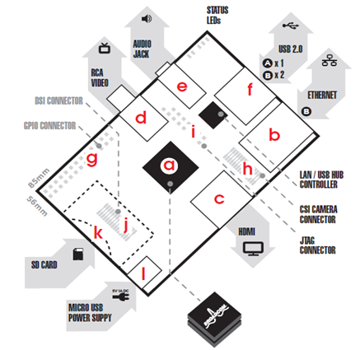

Figure 3: Specification Diagram

1. **Specifications**

|  |  |
| --- | --- |
| Specifications |  |
| Chip | Broadcom BCM2836 powered Single Board Computer (a) |
| Core architecture | Arm7 Quad Core Processor |
| CPU | 900 MHz Low Power ARM1176JZFS Applications Processor |
| GPU | Broadcom VideoCore IV @ 250 MHz  OpenGL ES 2.0 (24 GFLOPS)  MPEG-2 and VC-1 (with license), 1080p30 H.264/MPEG-4 AVC high-profile decoder and encoder |
| Memory | 1GB RAM shared with GPU |
| Operating System | Boots from SD card, running a version of the Linux operating system |
| Dimensions | 85.60 mm × 56.5 mm (3.370 inch × 2.224 inch) |
| Power | Micro USB socket 800 mA (4.0 W) |

Table 1: Specification of Raspberry Pi 2 Model B

1. **Connectors**

|  |  |
| --- | --- |
| Connectors |  |
| Ethernet | 10/100 BaseT Ethernet socket (b) |
| Video Output | HDMI (rev 1.3 & 1.4) (c); Composite RCA (PAL and NTSC) (d) |
| Audio Output | 3.5mm jack (e), HDMI |
| USB 2.0 | 4 x USB 2 Dual Connector (f) |
| GPIO Connector | 26-pin 2.54 mm (100mil) expansion header: 2x13 strip  Providing 8 GPIO pins plus access to I²C, SPI and UART as well as +3.3 V, +5 V and GND supply lines (g) |
| Camera Connector | 15-pin MIPI Camera Serial Interface (CSI-2) (h) |
| JTAG | Not populated (i) |
| Display Connector | Display Serial Interface (DSI) 15 way flat flex cable connector with two data lanes and a clock lane (j) |
| Memory Card Slot | SDIO (k) |

Table 2: Connectors of Raspberry Pi

**2.2 SIM 900-TTL UART GSM/GPRS MODEM**

2.2.1 What is the SIM 900-TTL UART GSM MODEM?

GSM/GPRS TTL -Modem from rhydo LABZ is built with SIMCOM Make SIM900 Quad-band GSM/GPRS engine, works on frequencies 850 MHz, 900 MHz, 1800 MHz and 1900MHz. It is very easy to use as plug in GSM Modem as it is of very small size. The 3V3/5V TTL interfacing circuitry, is used for designing the MODEM which allows direct interface to 5V microcontrollers( PIC, Arduino, AVRect) as well as 3V3 Microcontrollers ( ARM,ARM Cortex XX, etc) .The range 9600-115200 is the baud rate which can be configurable from through AT command. Initially Modem is in Autobaud mode. This GSM/GPRS TTL Modem connects with internet via GPRS through internal TCP/IP stack . The GSM modem requires only two wires (Tx, Rx) except Power supply to interface with microcontroller/Hos. It is suitable for DATA transfer applications well as SMS in M2M interface. The connection of wide range of unregulated power supply (4.2V -13V) is due to the built in Low Dropout Linear voltage regulator.

2.2.2 Features

1. Quad-Band GSM/GPRS 850/ 900/ 1800/ 1900 MHz
2. Configurable baud rate
3. SMA connector with GSM L Type Antenna.
4. Built in SIM Card holder.
5. Built in Network Status LED
6. Audio interface Connector
7. Normal operation temperature: -20 °C to +55 °C
8. Input Voltage: 5V-12V DC
9. 3V3 or 5V interface for direct communication with MCU kit
10. Inbuilt Powerful TCP/IP protocol stack for internet data transfer over GPRS.
11. High Quality Product
12. Most Status & Controlling Pins are available at Connector

2.2.3 Specifications

1. Quad-Band 850/ 900/ 1800/ 1900 MHz
2. GPRS multi-slot class 10/8
3. GPRS mobile station class B
4. Compliant to GSM phase 2/2+

* Class 4 (2 W @850/ 900 MHz)
* Class 1 (1 W @ 1800/1900MHz)

1. Dimensions: 24*24*3mm
2. Weight: 3.4g
3. Control via AT commands (GSM 07.07 ,07.05 and SIMCOM enhanced AT Commands)
4. Low power consumption: 1.0mA(sleep mode)
5. Operation temperature: -40°C to +85 °C

# 2.3 Edimax EW-7811Un 150Mbps 11n Wi-Fi USB Adapter

2.3.1 Features

1. Spec Standards IEEE 802.11n; backward compatible with 802.11b/g Wi-Fi Certified. Security 64/128 bit WEP Encryption and WPA-PSK, WPA2-PSK security; WPS compatible IEEE 802.1X
2. Includes multi
3. Power Saving designed to support smart transmit power control and auto-idle state adjustment
4. Supports WMM (Wi-Fi Multimedia) Standard so that you can let different types of data have higher priority. It allows better streaming of real-time data such as Video, Music, Skype etc
5. Port 1 x 2.0 USB Type A. Wireless Data Rates Up to 150 Mbps. Modulation OFDM: BPSK, QPSK, 16-QAM, 64-QAM, DSSS. Frequency Band 2.4GHz - 2.4835GHz. Antenna internal chip antenna
6. Supports 150 Mbps 802.11n Wireless data rate - the latest wireless standard. Permits users to have the farthest range with the widest coverage. (Up to 6 times the speed and 3 times the coverage of 802.11b.).
7. language EZmax setup wizard
8. Channels (FCC) 2.4GHz : 1~11. Power Input USB Port (Self-Powered). Dimensions 0.28" x 0.59" x 0.73". Temperature 0 -40 degree C (32-104 degree F). Humidity 10 ~ 90% Non-Condensing. System XP/Vista/Win7, Mac, Linux
   1. **CANVAS**

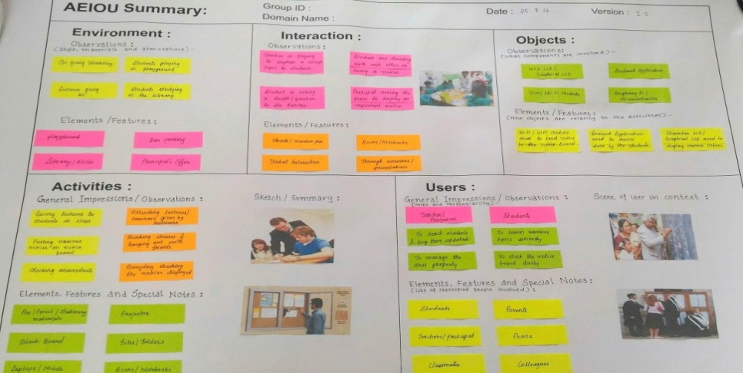

2.4.1AEIOU SUMMARY

Figure 4: AEIOU Summary canvas

There are basically five parts of AEIOU Canvas:

1. Activities
2. Environment
3. Interaction
4. Objects
5. Users
6. **Activities**

* General Impressions/Observations :

|  |  |
| --- | --- |
| Teacher | Student |
| Giving lectures to students | Attending lectures/seminars |
| Putting various notices on notice board | Bunking classes and hanging out with friends |
| Checking answer sheets | Everyday checking the notices displayed |

Table 3:General Impression activity of AEIOU Canvas

* Elements, Features and Special notes :
* Pen / Pencil / Stationary
* Blackboard
* Laptops / Mobile Phones
* Projector
* File / Folders
* Books / Notebooks

1. **Environment**

* Observations :
* Ongoing Workshops
* Ongoing Lectures
* Students studying in the Library
* Students playing in playground
* Elements /Features :
* Playground
* Bus parking
* Library
* Principal’s Office

1. **Interaction**

* Observations :
* Teacher is trying to explain a concept to students
* Student is asking doubts from the teacher
* Students are discussing with each other about a notice on the notice board
* Principal asking the peon to display an important notice
* Elements and Features :
* Chalk / Marker /Pen
* Notebooks /Books
* Verbal Interaction
* Through Seminars / Presentation

1. **Objects**

* Observations:
* 16X2 LCD / Graphical LCD
* Android Application
* GSM Module
* WIFI Module
* Raspberry Pi
* Elements and Features :
* Wifi / GSM module used to send notice to notice board
* Android application used to access data by the students
* Character LCD / graphical LCD used to display various notices

1. **Users**

* General Impressions and Observations:

|  |  |
| --- | --- |
| Teachers | Students |
| To teach students and keep them updated | To learn various topics sincerely |
| To manage the class properly | To check the notice board daily |

Table 4: General Impressions and Observations of users under AEIOU

* Elements , Features and Special Notes :
* Students
* Parents
* Teachers
* Principal
* Peons
* Classmates
* Colleague
  + 1. **EMPATHY CANVAS**

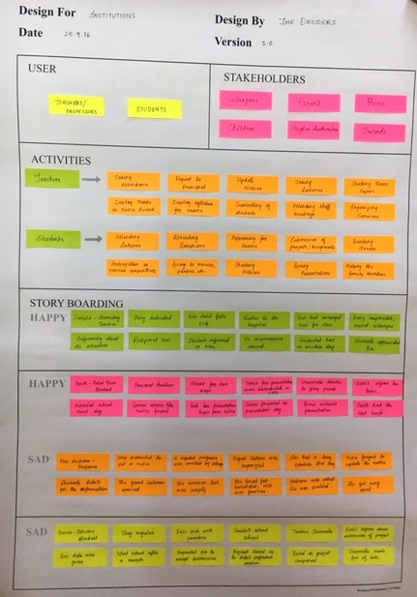

Figure 5: Empathy Canvas

There are basically four parts of Empathy Canvas:

1. User
2. Stakeholders
3. Activities
4. Story Boarding
5. **User**

* Teachers / Proffesors
* Students

1. **Stakeholders**

* Colleagues
* Parents
* Peons
* Children
* Higher Authorities
* Friends

1. **Activities**

|  |  |
| --- | --- |
| Teachers | Students |
| Taking Attendance | Attending Lectures |
| Report to Principal | Attending Seminars |
| Update notices | Appearing for exams |
| Taking lectures | Submission of projects / assignments |
| Checking Exam Papers | Bunking classes |
| Display Marks on Notice Board | Participation in various competitions |
| Display Syllabus for exams | Going to movies, parties etc. |
| Counselling of students | Checking Notices |
| Attending staff meetings | Giving presentations |
| Organizing Seminars | Helping the family members |

Table 5: Activities classification under Empathy canvas

1. **Story Boarding**

* **HAPPY STORY**

1. Sunita is a Chemistry Teacher. She is very dedicated towards her duties as a teacher, as well as towards her family. One day, her child falls sick, and she had to rush him to the hospital. She had arranged a test in the school for her class. Being a responsible teacher, she texted her colleague and told him to inform the students that the test would have to be postponed, as she did not want the students’ time to be wasted. Hence, no inconvenience was caused to anyone and everyone appreciated her dedication.
2. Parth is a final year student. He wasn’t able to attend the class on a particular day due to some personal problem. On that day, presentation topics were distributed by the teacher. His fellow classmates decided to play a prank and did not inform him about the presentation. Parth came back the next day, and comes across a notice on the notice board which his teacher had displayed. It contained the list of all the topics along with the roll number of the student who had to present it. So, he came prepared on the day of presentation and gave a vibrant presentation. The prank went unsuccessful.

* **SAD STORY:**
* Mrs Archana is a professor in a College. One day, the Principal instructed her to put a notice on the notice board regarding an Expert Lecture which was organized and a reputed faculty was going to come to deliver the lecture. Archana had a very hectic schedule that day, and because of that, she forgot to put up the notice. On the day of the Expert Lecture, no student showed up. The Guest Lecturer felt humiliated and the Principal was furious. Archana got scolded.
* Arnav is a sincere student, very regular in the classes. He falls sick with Jaundice and hence wasn’t able to attend classes for almost a month. His classmates were all jealous of him and hence did not inform him about the submission of a project which was due at the end of the month. Arnav went school after recovery and found the professor has failed him in the project component. He requested sir to accept the submission as he was sick and did not know about the submission. But the professor was furious as Arnav did not inform him in about his condition earlier. Classmates made fun of him and he got depressed.
  + 1. **IDEATION CANVAS**

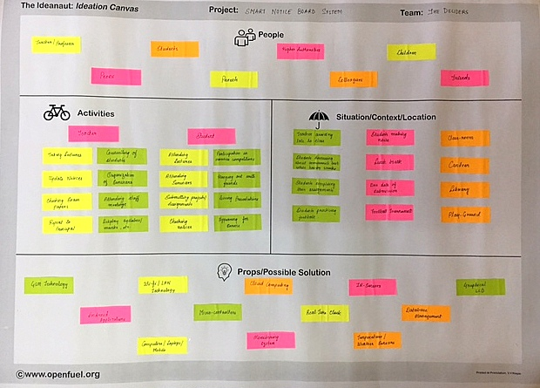

Figure 6 : Ideation canvas

There are basically four parts of Ideation Canvas:

1. People
2. Activities
3. Situation / Context / Location
4. Props / Possible Solution
5. **People**

* Teachers / Proffesors
* Students
* Higher Authorities
* Children
* Peons
* Parents
* Colleagues
* Friends

1. **Activities**

* Teacher
* Taking Lectures
* Counselling Students
* Update notices
* Organization of students
* Checking Exam Papers
* Attending Staff meetings
* Report to principal
* Display Syllabus / marks etc.
* Student
* Attending Lectures
* Participation in various competition
* Attending Seminars
* Hanging out with friends
* Submitting projects / assignments
* Giving presentation
* Checking notes
* Appearing for exam

1. **Situation / Context / Location**

|  |  |  |
| --- | --- | --- |
| **Situation** | **Context** | **Location** |
| Teacher arriving late to class | Students making noise | Classroom |
| Student discussing about tomorrow’s test while having snacks | Lunch Break | Canteen |
| Students completing their assignments | Due date of submission | Library |
| Student practicing football | Football Tournament | Playground |

Table 6 : Situation /context/ location classification

1. **Props / Possible solution :**

* GSM technology
* Android Application
* Wifi / LAN technology
* Computers / Laptops / Mobile
* Microcontroller
* Cloud Computing
* Monitoring System
* Real Time Clock
* IR Sensor
* Temperature Weather Sensor
* Database Management
* Graphical LCD

2.4.4 **PRODUCT DEVELOPMENT CANVA**S 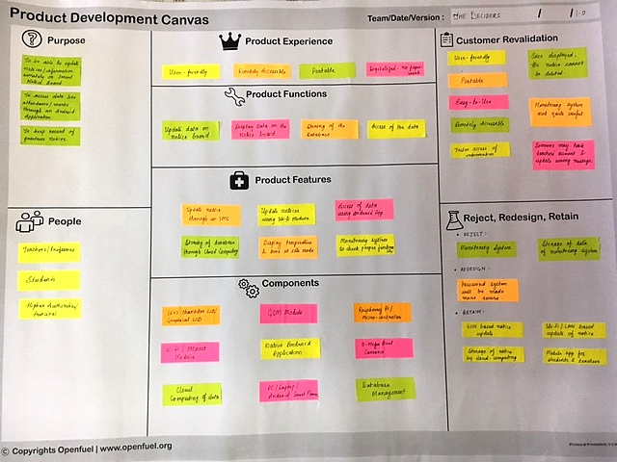

Figure 7: Product Development Canvas

There are basically eight parts of Product Development Canvas:

1. Purpose
2. People
3. Product Experience
4. Product Function
5. Product Features
6. Components
7. Customer Revalidation
8. Reject / Redesign and Reatain
9. **Purpose :**

* To be able to update notices / information remotely on smart notice board
* To access data like attendance, marks through an android application
* To keep record of previous notices

1. **People :**

* Teacher /Professor
* Student
* Higher Authorities / Principal

1. **Product Experience :**

* User Friendly
* Remotely Accessible
* Portable
* Digitalized

1. **Product Function :**

* Update data on notice board
* Display data on notice board
* Storing of data in database
* Access of the data

1. **Product Features :**

* Update notices through an sms
* Update notices using Wifi module
* Access of data using Android Application
* Storing of database through cloud computing
* Display temperature and time in idle mode
* Monitoring System to check proper functionality

1. **Components :**

* 16X2 LCD / Graphical LCD
* Wifi / Ethernet Module
* GSM Module
* Raspberry Pi
* Cloud Computing of data
* Native Android Application
* 3 Mega Pixel Camera
* PC / Laptop / Android Smart Phone
* Database Management

1. **Customer Revalidation :**

* User Friendly
* Portable
* Easy to use
* Remotely Accessible
* Faster access of information
* Once displayed, the notice cannot be displayed
* Monitoring system not quite useful
* Someone may hack teacher’s account and update wrong message

1. **Reject , Redesign and Retain :**

* Reject :
* Monitoring system
* Storage of data of monitoring system
* Redesign :
* Password system would be made more secure
* Retain :
* GSM based Notice Board
* Wifi / LAN based update of notice
* Storage of notice by cloud computing
* Mobile application for student and teachers
  + 1. **BUSINESS MODEL CANVAS**

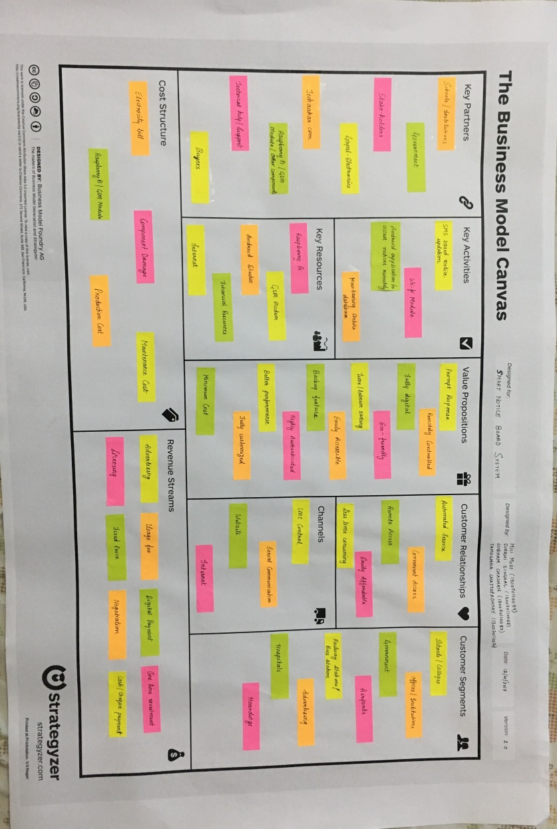

**Fig8 :**Business Model canvas

**1. KEY PARTNERS**

* Schools / Institutions
* Government
* Stake Holders
* Techarkar.com
* Raspberry pi / GSM
* Byers

1. **KEY ACTIVITIES**

* SMS based notice updating
* WiFi module
* Android application to access notice remotely
* Maintain online database

1. **KEY RESOURCES**

* Raspberry pi
* GSM Modem
* Android Studio
* Financial Resources

1. **VALUE PROPOSITION**

* Prompt Response
* Remotely Controlled
* Fully Digital
* Eco friendly
* Time labour saving
* Easily accessible
* Backup feature
* Highly authenticated
* Better performances
* Minimal cost

1. **COSTUMER RELATIONSHIP**

* Automated service
* Convenient access
* Remote access
* Easily affordable
* Less time consuming

1. **CHANNELS**

* SMS control
* Serial communication
* Website
* Internet

1. **COSTUMERS SEGMENT**

* Schools/offices
* Institution
* Government
* Airport
* Railway station
* Advertising
* Hospital
* Hoarding

1. **COSTS STRUCTURE**

* Electric bill
* Raspberry pi / GSM
* Component damage
* Production cost
* Maintenance cost

1. **REVENUE STREAMS**

* Advertising
* Digital payment
* One time investment
* Licensing
* Fixed price
* Negotiable
* Cash/ cheque pay

**Chapter 3**

**BLOCK DIAGRAM, PROJECT DESIGN AND SYSTEM COMPONENTS**

CHAPTER 3 BLOCK DIAGRAM AND COMPONENTS

**3.1 BLOCK DIAGRAM**

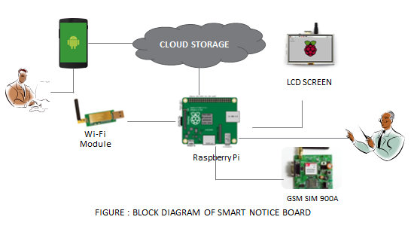

Figure 9: BASIC BLOCK DIAGRAM

**3.2 COMPONENTS USED**

* Raspberry Pi
* Sim900A Modem with TTL
* Edimax EW-7811Un 150Mbps 11n Wi-Fi USB Adapter
* Graphical LCD

**3.3 PROCESS FLOW**

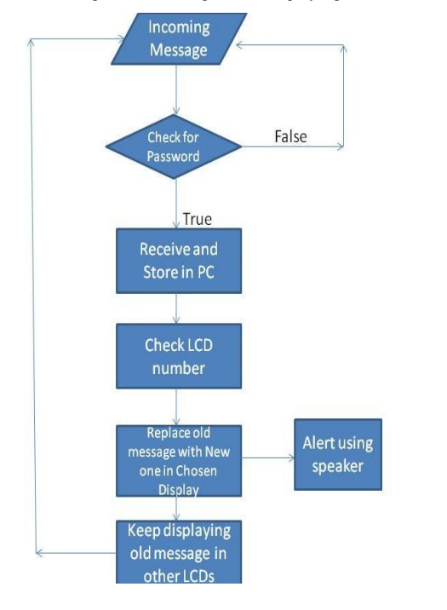

Figure- 10 : FLOW DIAGRAM OF THE SYSTEM

* 1. **OVERVIEW TO COMPONENTS USED**
* Displaying unit consists of LCD and Graphical LCD.
* The message comes from an authorized mobile phone using GSM technology or from laptops using WiFi receiver.
* When an authorised user sends a notice from his system, it is received by Wi-Fi receiver.
* The reception of data from authenticated user is decoded , and connected to raspberry pi using SPI protocol.
* The raspberry pi provides the TCP/IP stack for RN-171 with static IP address and it also configures Graphic LCD to display notice.
* The same output data from raspberry pi is send to µVGA (VGA module) , which displayed on general LCD monitor.
* An Android Application will be made through which authorised users can access this online databse to go through the notices stored there.
* Using OwnCloud, you can sync and share your private data, and access it from any device connected to the internet. For added security, OwnCloud can also encrypt your files. The software can handle files in a variety of formats and you can extend its usability by adding a number of other apps.
* Raspberry Pi is interfaced with displaying unit.
* OwnCloud is one of the best pieces of opensource software to help you create your own private and protected cloud-sharing service.
* So an online database will be created on OwnCloud which will be linked to the Raspberry Pi. The notices will be stored in this database.
* Cloud computing is a type of Internet-based computing that provides shared computer processing resources and data to computers and other devices on demand.

**3.5HOW TO LOAD OS IN RASPBERRY PI USING WINDOWS 8**

* To load the operating system on raspberry pi we required below software.
* SD Card Formatter
* Window32 Disk Imager
* What are the stuffs required to do this?
* Raspberry Pi.
* Ethernet Cable.
* Laptop.
* SD Card with Raspbian.
* Micro USB Cable.

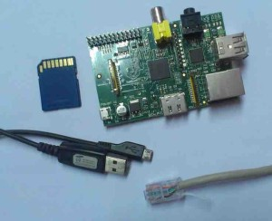

Figure11: Stuffs Required to Load OS in Raspberry Pi

1. **Download the Raspbian image from raspberrypi.org**

* Official images for recommended Operating Systems are available to download from the Raspberry Pi website: raspberrypi.org/downloads.
* After downloading the .zip file, unzip it to get the image file (.img) for writing to your SD card.

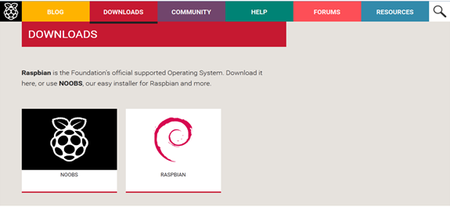

Figure 12: Raspbian Image

1. **Download the win32disk imager for the loading image on to SD card.**

* The downloading site is sourceforge.net/projects/windows/32diskimager.

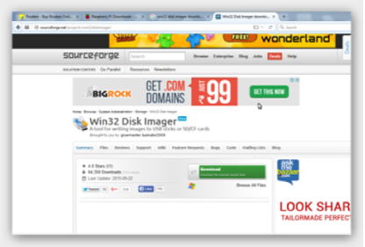

Figure13: Win32disk Imager

1. **Format the SD card using the SD format software.**

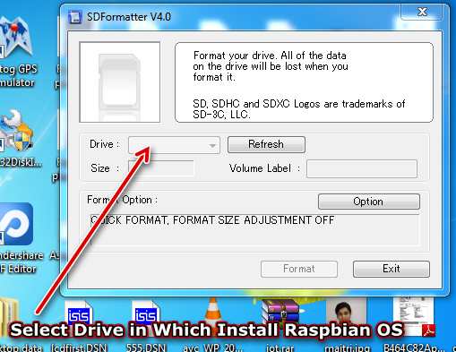

Figure14: SD Card Formatting

1. **Load the image into the SD card using win32 disk imager.**

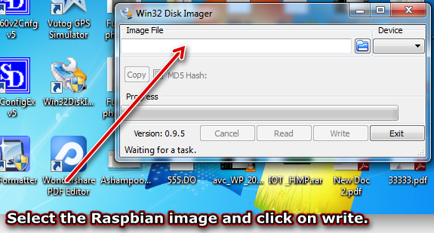

Figure15: Loading the Image using Win32Disk Imager

1. **After successful loading the image, remove the SD card from PC and insert in to the Raspberry Pi.**

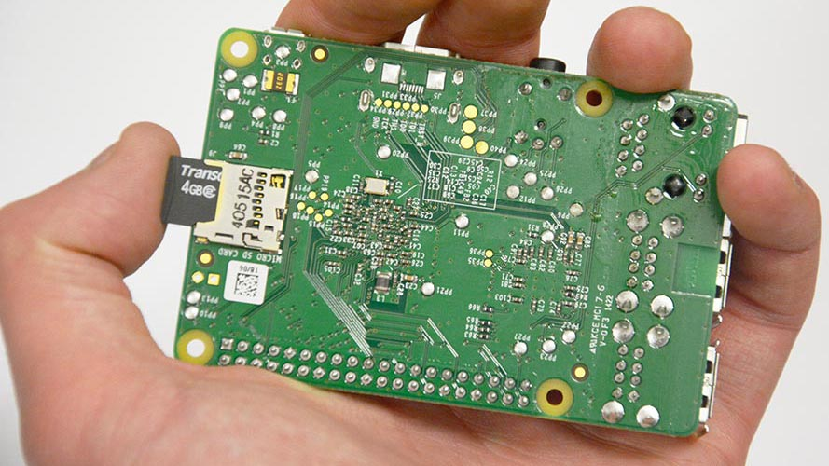

Figure16: Insert SD Card to Raspberry Pi

**3.6HOW TO ACCESS RASPBERRY PI USING ETHERNET CABLE**

Raspberry Pi is minicomputer board. So it is required to use keyboard, mouse and display for its operation. But if we want use PC/Laptop to operate the Raspberry PI then we need to use secured cell protocols.

To use those protocols we need to use below software’s….

1. Putty

Follow the installation; including installing “Putty” if you don’t have it already. You can also download “Putty” separately from http://www.putty.org/

1. Xming

Download and run <http://sourceforge.net/projects/xming/> from the [Xming](http://people.arsc.edu/~murakami/xming/) site.

1. **Give supply to Raspberry PI using data cable and connect the Ethernet cable from Raspberry Pi to PC.**

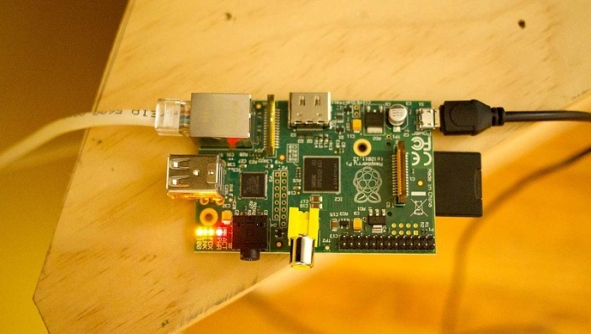

Figure17: Supply, Ethernet and Data Cable Connection to Pi

1. **Check the IP address of the machine by executing the below command**

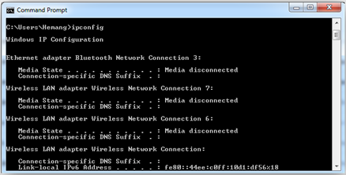

Figure18: Command to Check IP Address of Machine

1. **Remove the power supply and the SD card from Raspberry Pi and inset SD card to the PC.**
2. **Open the cmdline.txt file from the SD card and at the end of line, insert the IP address of Raspberry Pi.**

Insert the below line.

Ip = 192.168.146.1

1. **If we want to share the internet to the Raspberry Pi then insert the IP address in following manner.**

Ip = IP of Raspberry Pi::IP of PC (i.e. 192.168.146.1::192.168.146.2)

1. **Save the cmdline.txt file and remove the SD card from PC and insert in to Raspberry Pi.**
2. **Check the connection between the Raspberry Pi and PC by executing following command.**

Ping (IP address of PC) i.e. ping 192.168.1.68

Ping (IP address of Raspberry Pi) i.e. ping 192.168.1.69

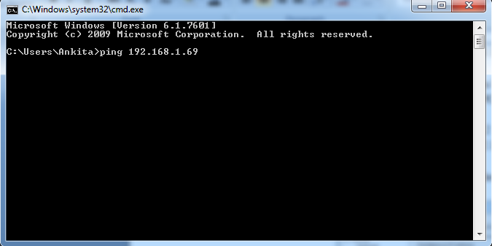

Figure19: Command to Check Connection between Pi and PC

1. **Open the Putty software and go to session and enter the IP address of Raspberry Pi in dialog box**.

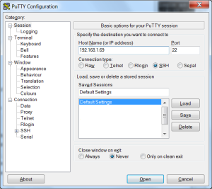

Figure 20: PuTTY Configuration1

1. **Go to SSH>X11> and enable X11 forwarding.**

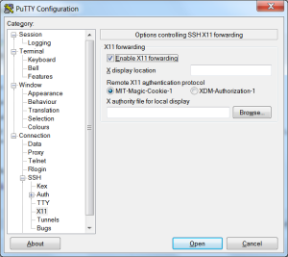

Figure 21: PuTTY Configuration2

1. **We get the following window. In that window enter the user name-pi and password- raspberry which is by default for Raspberry Pi.**

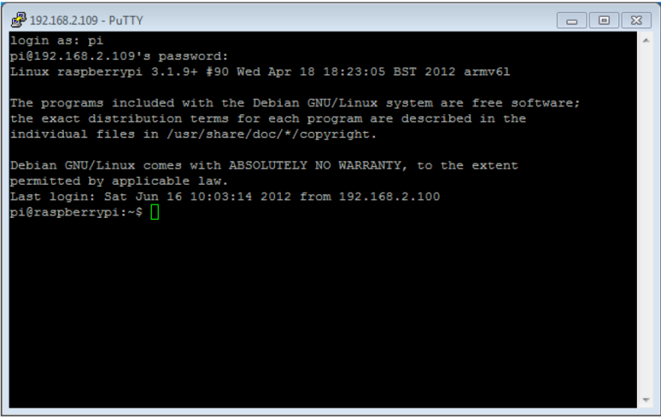

Figure 22: window- PuTTY

1. **After this on same window pi terminal is open.**

Now if we want to see the desktop of raspbian OS then we need to install the VNC server on to the Raspberry Pi by using the following command.

**Sudo apt get-install xtightvnc server**

The following command is general command to installing any application onto the Raspberry Pi

**Sudo apt get-install application name**

Now if we want to see the desktop then execute the following command.

**Lxssesion**

After that we got the following desktop screen on window.

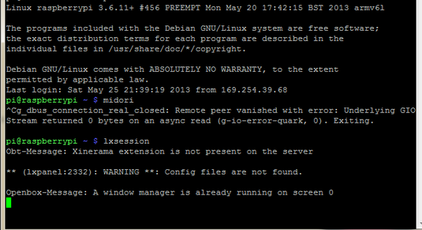

Figure 23: Window Pi Terminal

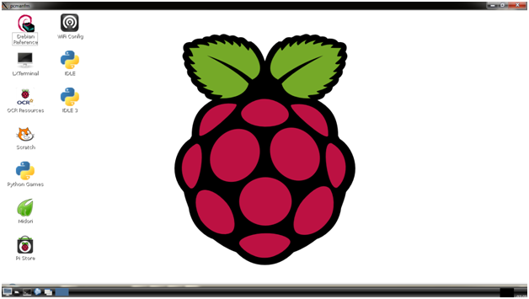

Figure 24: Desktop Screen on Window

Connection is successfully established between the raspberry pi and PC, an internet connection can be also access from raspberry pi and can check the internet connection from browser using raspberry pi. The official language for raspberry pi is python. We can use this language for making small and bigger application using raspberry pi.

**CHAPTER 4**

**INTERFACING RASPBERRY Pi 3 WITH VARIOUS MODULES**

CHAPTER 4 INTERFACING RASPBERRY Pi3 WITH VARIOUS MODULE

**4.1 Interfacing GSM Modem SIM900Awith Raspberry Pi**

* GSM Modem is almost equivalent to a mobile communication system as operates over a subscription to a mobile operator.
* From the mobile operator perspective, a GSM modem looks just like a mobile phone.
* Using the transmission and reception pins, a modem can receive and send the messages and it could be interfaced with the PC or to a microcontroller or Raspberry Pi.
* This property makes the modem to exist in a relevant position on embedded applications.
* Raspberry Pi is a high end embedded device, so an interface with a GSM modem will result in the invention of an intelligent system.

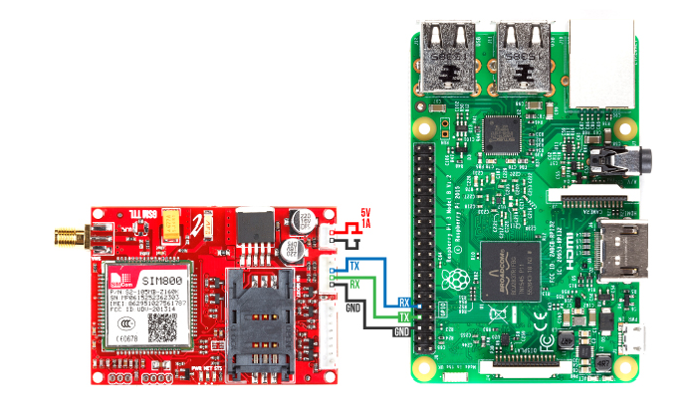

Figure 25 : Interfacing of GSM with Raspberry Pi

**Modules Required:**

1. Raspberry Pi 3

2. GSM Modem SIM900A

3. A 5V battery or power supply

4. Connecting wires

5. A mobile phone

6. An extra SIM card

**Steps:**

* Insert a SIM card in to the GSM modem and make the suitable connections as shown in the figure. A suitable factor that we kept in mind is that, the sim used in the module was having enough balance to send the sms and it was kept in a place having appropriate range for that particular network.
* The transmission and reception pins should be connected in a reverse order and the ground pins must be shorted.  Power up the GSM module and wait for few seconds for sim initialization.
* Now we will be sending and receiving messages through this modem with the help of a python script.
* In the code, import the proper libraries and enable the serial communication. Modem control is done through AT commands, so suitable commands should be transmitted to the modem for each purpose and the modem will respond to these commands by transmitting suitable messages that should received and display it on the python shell.
* The suitable message will be received by the mobile number given in the code.
* Similarly, we can now retrieve the SMS received via GSM Modem using a python script .
* As a result, the message will be displayed on the python shell.
* Hence, in this way our smart notice board system will be receiving the notices to be displayed through an SMS.

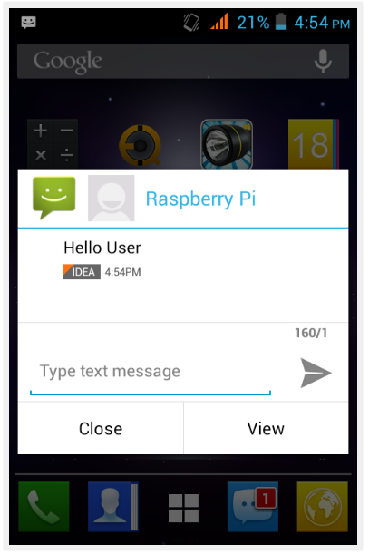

Figure 26 : Sending message to Raspberry Pi

* 1. **INTERFACING OF RASPBERRY Pi 3 WITH WIFI**

**Setting up Wi-Fi via the Graphical Interface**

 This process is probably the most effective method of connecting to your Wi-Fi and also the quickest.

1. In the Desktop environment locate the network icon in the top right hand side and click on the icon to see the list of available Wi-Fi networks to connect to.

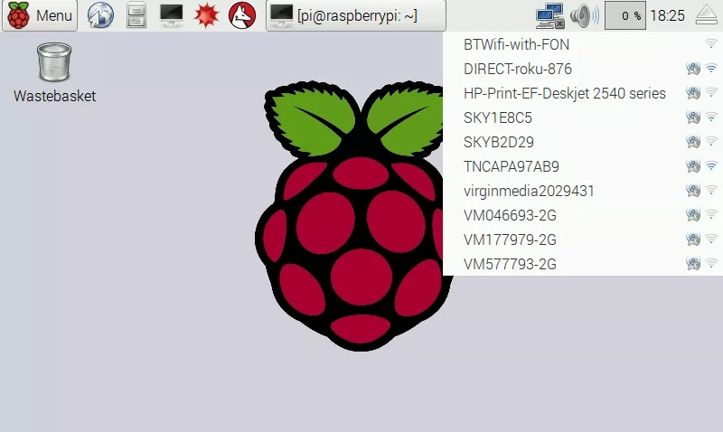

Figure27 : ON the wifi module on raspberry pi

1. Select your [Wi-Fi](https://www.digikey.com/en/maker/blogs/raspberry-pi-3-how-to-configure-wi-fi-and-bluetooth/03fcd2a252914350938d8c5471cf3b63) SSID in the drop down list

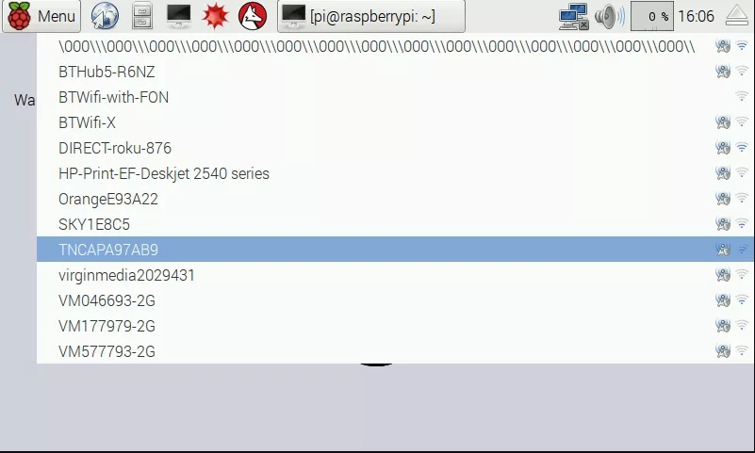

Figure28 : select the wifi network

1. You will be prompted to enter your  [Wi-Fi](https://www.digikey.com/en/maker/blogs/raspberry-pi-3-how-to-configure-wi-fi-and-bluetooth/03fcd2a252914350938d8c5471cf3b63) password into the text box, so go ahead and do so

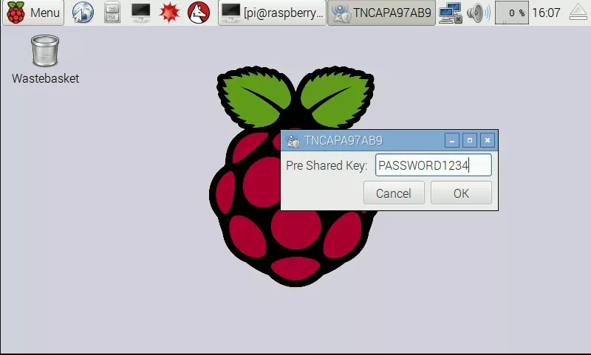

Figure 29 : Entering the passkey

1. Click ok and you will be connected to your [Wi-Fi](https://www.digikey.com/en/maker/blogs/raspberry-pi-3-how-to-configure-wi-fi-and-bluetooth/03fcd2a252914350938d8c5471cf3b63). You should now see your signal strength displayed in the upper task bar on the right connected to your [Wi-Fi](https://www.digikey.com/en/maker/blogs/raspberry-pi-3-how-to-configure-wi-fi-and-bluetooth/03fcd2a252914350938d8c5471cf3b63) successfully; test your connection by opening up the web browser.
   1. **DEVELOPING OF AN ANDROID APP**

**Introduction**

* The idea is to make an android app for students.
* Each student will be provided a login ID and password.
* The updated notices, and information can be directly accessed from that app.
* The app will be supported by a CLOUD backend.

**ANDROID STUDIO**

* Development of android app requires an IDE(integrated development environment).
* The most commonly used IDE are Android Studio and Eclipse.
* There are various advantages of using Android Studio over Eclipse.
* Because of this, we’ll be using Android Studio for app development.

**Creating a Basic App using AS**

* **STEP 1: Install Android Studio**

**[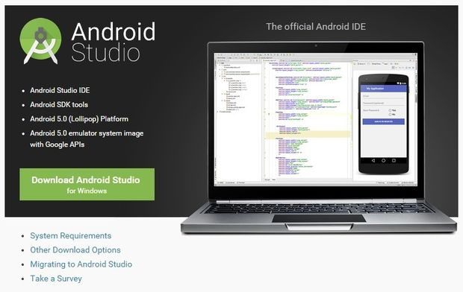](http://www.instructables.com/file/FEBX9MXI7MXG4I1/)**

Figure 30 : installation of android app

* **STEP 2: Open a New Project**

**[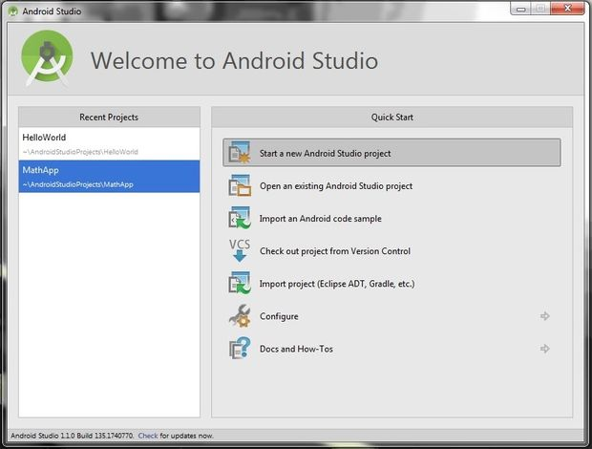](http://www.instructables.com/file/FIA90KGI7MXG4IA/)**

Figure 31: Selection of the project

**Step 3: Edit the Welcome Message in the Main Activity**

**[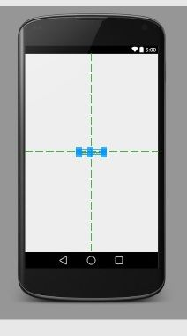](http://www.instructables.com/file/FLHQ3QMI7MXG4HY/)[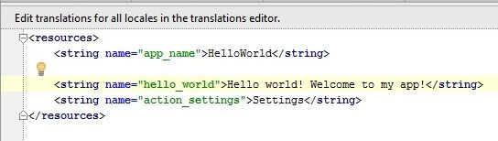](http://www.instructables.com/file/FG53NYVI7MXG4NP/)**

Figure 32: Editing of welcome message

* **Step 4: Add a Button to the Main Activity**

**[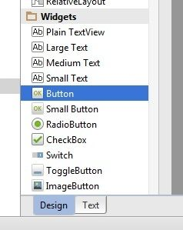](http://www.instructables.com/file/FE60OS4I7MXG4NQ/)**

Figure 33: Adding activity button

* **Step 5: Create a Second Activity**

**[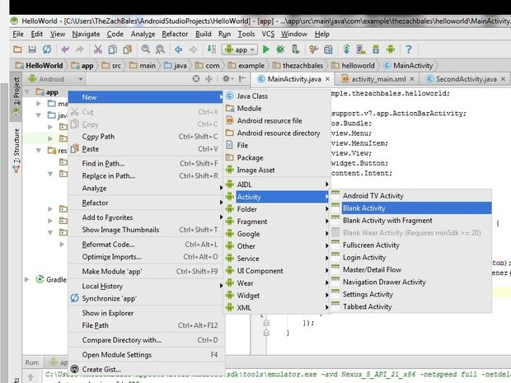](http://www.instructables.com/file/F65D7O2I7MXG4I6/)**

Figure 34 : Addition of second activity button

* **Step 6: Write the Button's "onClick" Method**

**[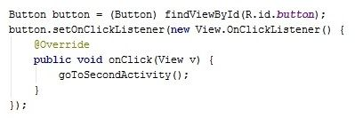](http://www.instructables.com/file/FGSOB2UI7MXG4I8/)**

Figure 35 : Button’s on click method

* **Step 7: Test the Application**

**[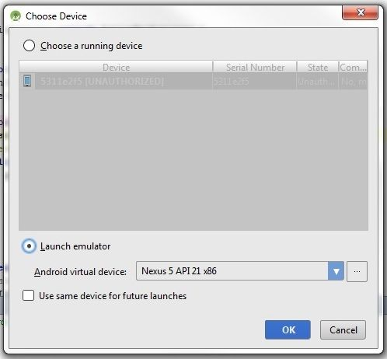](http://www.instructables.com/file/FX9AJOJI7MXG4HZ/)**

Figure 36 : Testing the application

* 1. **INTERFACING OF RASPBERRY WITH GOOGLE DRIVE**

Google Drive is the world’s most popular cloud storage system offering that enables us to store your documents, photos, music, videos etc. all in one place. It automatically syncs all our data with our mobile devices and our computer, meaning every device that is linked to our account receives the updates and shows the changes we have made. For individual users who require basic sharing capacity and storage up to 15 GB, Google Drive comes for free. The most we can pay for it is $299.99 for 30 TB of storage.

Google Drive monitors our changes too for the past 30 days, enabling us to go back and redo/undo the changes we made. The platform relies heavily on Google search and makes use of familiar Google features such as image recognition for browsing our photos and some OCR capabilities for sniffing out text in pictures.

**Google Drive Benefits:**

As Google Drive is a cloud-based application, you can easily access everything from any computer or mobile if you have internet connectivity. Google Drive is very user-friendly and is a great option for businesses in search of a reliable office suite, yet do not have the funds to invest in expensive office programs. Google Drive comes with the tools and features that have proven to be great for business collaboration and internal communication, such as Google Calendar, Hangouts and more. What this means is that with a single Google account, you will be able to manage all of your contacts and business needs using a variety of handy system.

The core value of Google Drive is that it offers sufficient storage at no added cost. You have massive storage capacity already in your hands, meaning you can store a lot of files without losing any space. Except of sharing your files with other users, Google Drive will allow you to search among them, and edit them online, individually or in a group. Then, if you need to purchase additional GBs, you’ll be happy to know that you can get 100GB for just $1.99 a month. If you are using it for personal purposes and need no more than 15 GB storage, Google Drive won’t charge you for the service.

But perhaps Google Drive’s greatest selling point is that it works well with third-party business apps, making it a popular cloud-based storage and sharing application for individuals and businesses alike. There are hundreds of reputed business systems and applications already embedded on the list, and the number is continuing to grow.

The main problem of using cloud storage services like Owncloud is the charges taken when the number of user increase. As our project deals with a large number of users who can access the drive to view notices, the OwnCloud platform is not suitable for our use.

**Backing up Pi on the cloud**

Being able to back up data to the cloud is very useful. It means that even if your Raspberry Pi dies or your SD card gets corrupted, your data is still safe. It also means that you can access your data from anywhere in the world.

If you have a Google drive account, you can use the grive program to sync a folder on your Pi with your Google drive.

**CHAPTER 5**

**PRACTICAL WORKING OF MODEL**

CHAPTER 5 PRACTICAL WORKING OF MODEL

**STEPS :**

1. **Using putty to access the raspberry pi and run the python program.**

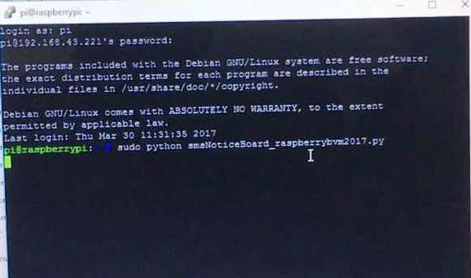

Figure 37 : Running python program

1. **Checking all the components are connected and functioning properly.**

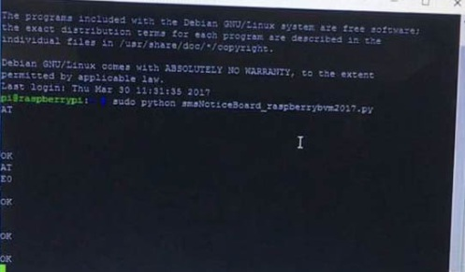

Figure 38 : Python program checks the connectivity

1. **Sending SMS notice from the approved mobile number**

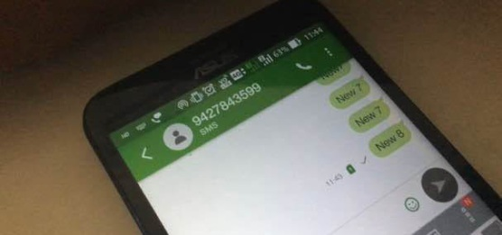

Figure 39 : Sending message through sms

1. **Message displayed on notice board connected and controlled by raspberry pi**

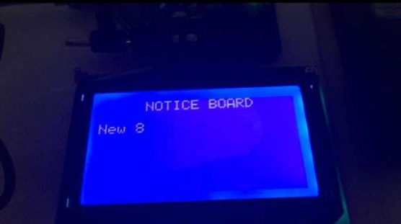

Figure 40 : Message displayed on Lcd screen

1. **Message stored on online google sheet when received.**

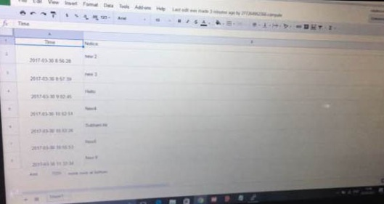

Figure 41 : Message stored on google sheet

1. **Message accessed by android app created for accessing the notice board.**

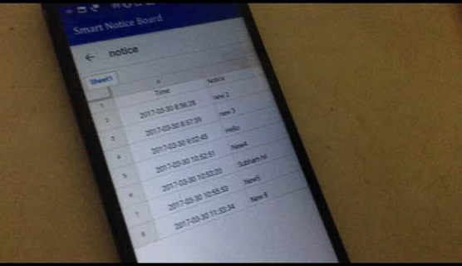

Figure 42 : accessing message through android app

**Chapter 6**

**SUMMARY**

CHAPTER 6 SUMMARY

**SUMMARY**

After the completing all the work of this semester, at the end of the semester we have achieved a basic understanding of the requirements behind our project and have already started implementing the project on our hardware. We are on the verge of implementing the different modules and their interfacing with the raspberry pi. We hope to do so in the following semester.

**6.1ADVANTAGES**

* Provides facilities of observing and reading notices to remote students
* This system is more reliable and safe because we can access the system from remote place over the web server
* This system is more secure because only the selected persons can access the system through given username and password
* The system removes the tedial nature of manual notices being delivered all over the organisation

**6.2FUTURE WORK**

* Interface the GSM module with raspberry pi.
* Interface the wifi module with raspberry pi.
* Interface GLCD with raspberry pi.
* Construct an android application to access online database where all the notices will be stored.
* Interface raspberry pi with OpenCloud through cloud computing.

**REFERENCES**

1. <http://raspberrypihq.com/how-to-add-wifi-to-the-raspberry-pi/>
2. <https://www.maketecheasier.com/setup-wifi-on-raspberry-pi/>
3. <https://www.raspberrypi.org/blog/the-eagerly-awaited-raspberry-pi-display/>
4. <http://www.circuitbasics.com/setup-lcd-touchscreen-raspberry-pi/>
5. <http://learningembedded.com/>
6. <http://www.rhydolabz.com/wiki/?p=10450>
7. http://www.raspberrypi-spy.co.uk/2012/07/16x2-lcd-module-control-using-python/
8. http://www.instructables.com/id/Connecting-16x2-LCD-with-Raspberry-Pi/
9. http://ozzmaker.com/2013/10/04/interface-16x2-lcd-with-the-raspberry-pi/
10. http://ww2.rpiblog.com/?folio=7POYGN0G2
11. https://learn.adafruit.com/downloads/pdf/drive-a-16x2-lcd-directly-with-a-raspberry-pi.pdf
12. engineersgarage.com
13. raspberrypi.org
14. sunrom.com
15. https://www.youtube.com/watch?v=IbKMQgjUQwk
16. https://www.youtube.com/watch?v=eHQvmlae97A
17. https://en.wikipedia.org/wiki/Raspberry_Pi
18. https://www.adafruit.com/category/105
19. www.modmypi.com/raspberry-pi
20. http://www.robertawood.com/blog/raspberry-pi/raspberry-pi-initial-setup-headless-no-monitor-or-keyboard-needed.html
21. http://www.dexterindustries.com/howto/connecting-raspberry-pi-without-monitor-beginners/
22. http://n00blab.com/how-to-set-up-raspberry-pi-without-monitor/